Whareama School
www.whareama.school.nz
Newsletter No. 6
12th March, 2018
Term 1, Week 7

CURRICULUM
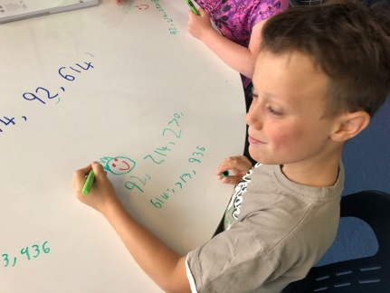
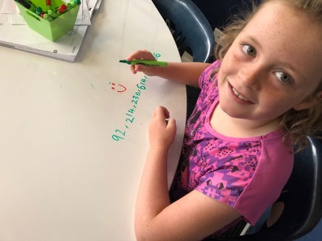
Both classes continue to work hard in all the areas of the curriculum. There have been some very impressive pieces of writing come from both the Junior and Senior Rooms and many of these are being shared on Seesaw. Please make sure that you have access to your child’s account and if you are not on board yet please ask your teacher to help you do this at our interviews this week. Make sure you bring the device you want to add it to, as well as the Seesaw Parent app downloaded onto your device and we can help you from there. I was really impressed with pieces of writing from Poppy and Josh this week and have included a snippet from their writing at the bottom of this newsletter. This term is flying by and I look forward to catching up with you all at our interviews to discuss your child’s learning skills and also where we believe they need to focus on for 2018.

NGA TAMA TOA
This Tuesday Fontyne will be joining Mathew in the Nga Tama Toa course at MIS. This will be Mathew’s second year and Fontyne’s first. It is a great opportunity for these boys to learn haka, taiaha and waiata with tutors from around the lower North Island. There are 4 days this year and this is the first for the year.

DESIGN TECHNOLOGY
Due to a missing email we found out that Design Tech actually starts this Friday and will run through until the end of the term. Sorry for the confusion and hopefully this week the kids will be into their eagerly awaited courses!

SWIMMING
After school swimming lessons are on Monday and Tuesday this week. Congratulations to Oscar and Logan who qualified for the Wairarapa Swimming champs on this Wednesday night at the town pools. Both boys qualified in their respective freestyle events.

PEDAL READY
The Pedal Ready programme, for all Year 5 and 6 students, was a huge success. All students passed their Grade 1 course and can now qualify for the Grade 2 course. The Year 7 and 8 students will be doing this next term in town. Visit the Movin’ March website to see events near us that you can take part in for Movin’ March!

PARENT/ TEACHER/ STUDENT INTERVIEWS – to be held this week on Wednesday 14th and Thursday 15th March. See you all here, with your child, for our annual interviews.

SPORTS
Cricket: There was no cricket on Friday night, due to the weather.

Tennis: The Whareama Smashers played against Opaki Blue on Tuesday night and then played MIS Shots on Friday night and won both of their games. It is great to see these boys improving and enjoying their tennis this term.

Upcoming Events:
TERM 1:
Tues 13th March Nga Tama Toa – Mathew and Fontyne
Weds 14th/ Thurs 15th March Parent/ Teacher Interviews
Weds 14th March Wairarapa Swimming Sports
Fri 16th March Design Tech Starts – Yr 7/8
Weds 28th March Take a Kid Fishing Day – Logan/ Harrison/ Rane/ Poppy
Weds 28th March Kidz Conference
Fri 13th April Term 1 Ends

LUNCH ORDERS – WEEK 7
Please send in your order forms for this week’s lunches by Thursday.

Regards
Darren, Heather, Sandy and Diana

Snippet from Poppy Tatham’s writing titled: “A Palomino Pony”
The smoky grey eyes of a beautiful palomino pony looks straight at me. My heart seems to skip a beat and it dawns on me that this could possibly be my future pony……slowly I lead up a ramp, my face glowing in awe as the little pony obediently follows me. Beautiful. The word rings through my head, as I stare out the window of the car overlooking the rolling hills and paddocks. My mind drifts, as I wonder about all the adventures Smarty and I will go on.

Snippet from Josh Fairbrother’s writing titled: “Nevaeh’s Creation”
It looks great. Who am I talking about? Well, let me tell you! He has big, googly eyes, he is black and soft and can you guess who it is? Well ok, I will tell you it is Wiggly. He is a big monster made from play dough and acorns. Run, run, run!!!! Good on you Nevaeh for using your brain in this creation.

